DATA ANALYSIS PROJECT REPORT
Programming in Python
Course Section B
The Chess Code
A Data-Driven Analysis of Chess Game Outcomes and Player Skill

Field | Details
Student Name | Din Muhammad Rezwoan
Student ID | 23-51712-2
Course / Section | Programming in Python / Section B
Dataset | Chess Game Dataset (Lichess)
Dataset Source | https://www.kaggle.com/datasets/datasnaek/chess
GitHub Repository | https://github.com/Rezwoan/The-Chess-Code
Date of Submission | 2nd May 2026

1. Executive Summary
This project investigates 17,431 competitive chess games from the Lichess platform using Python, Pandas, NumPy, and Matplotlib. The dataset was sourced from Kaggle and contains game metadata including player ratings, time controls, opening choices, and game outcomes. The analysis focused on three core questions: what factors determine how a chess game ends, which openings give white the best and worst win rates, and how opening preferences differ across skill levels. Key findings include that resign endings increase from 46.6% at Beginner level to 70.5% at Master level, confirming that self-awareness of a lost position improves with skill. Opening choice was found to have a measurable effect, with white win rates ranging from 31.6% to 67.8% across 54 openings. Opening preferences also shift noticeably by rating tier, with stronger players gravitating toward more theory-heavy openings.

2. Introduction and Project Objectives
Chess is one of the most studied strategic games in the world, with a vast body of theory built around openings, middlegame patterns, and endgame technique. Despite this, relatively little data-driven analysis exists at the amateur and semi-competitive level where most online games are played. This project uses a real dataset of Lichess games to investigate how skill level, time pressure, and opening choice influence game outcomes. The Lichess platform is one of the largest free chess servers in the world, making its game data representative of a wide range of player skill and playing styles.

Item | Details
Dataset Name | Chess Game Dataset (Lichess)
Dataset Source | https://www.kaggle.com/datasets/datasnaek/chess
Main Project Goal | Analyze patterns in how chess games end based on player skill, time control, and opening choice
Research Question 1 | What player and game factors determine how a chess game ends (resign, checkmate, or timeout)?
Research Question 2 | Which opening families give white the best and worst win rates, and does this vary by skill level?
Research Question 3 | How do opening preferences differ across rating tiers, and does rating influence game patterns?

3. Dataset Description
The dataset contains over 20,000 competitive chess games collected from the Lichess.org platform. Each row represents one complete game between two players. The data includes player usernames, ratings, time control settings, opening information in standard ECO notation, the full list of moves played, and the final outcome of the game. The dataset covers games played across a wide range of skill levels, from Beginner to Master, and across multiple time control formats including Bullet, Blitz, Rapid, and Classical.

3.1 Basic Dataset Information
Property | Value
Number of rows (raw) | 20,058
Number of rows (after cleaning) | 17,431
Number of columns (raw) | 16
Number of columns (final) | 24 (including engineered features)
Data types present | String, Integer, Float, Boolean, Categorical
Key variables | victory_status, winner, white_rating, black_rating, opening_name, increment_code
Issues at first glance | Missing values in white_rating, opening_eco, opening_name; timestamps unusable; increment_code requires splitting

3.2 Initial Observations
On first inspection, the dataset showed three columns with missing values: white_rating (300 rows, 1.5%), opening_eco (601 rows, 3.0%), and opening_name (802 rows, 4.0%). The winner column had no missing values as Lichess already records drawn games using the string "draw". The victory_status column was heavily imbalanced, with resign accounting for the majority of outcomes. The created_at and last_move_at timestamp columns stored Unix millisecond values with identical precision, making direct duration calculation impossible. The increment_code column stored both the time base and increment as a combined string (e.g. "5+3"), requiring parsing before use. The ratings column ranged from around 800 to 2700, covering a realistic range of Lichess player skill levels.

4. Data Cleaning and Preparation
The dataset required five cleaning steps before analysis. Each step addressed a specific problem identified during the initial inspection phase.

Issue Found | Action Taken | Justification | Notebook Section
Unusable timestamp columns and increment_code stored as string | Parsed increment_code into time_base and time_increment; computed game_duration_mins using formula: (time_base x 2) + (turns x time_increment / 60); dropped timestamp columns | Timestamps had identical precision making difference always zero. The formula gives a reliable theoretical estimate of game length using the clock settings | Section 3 - Step 1
Missing values in white_rating, opening_eco, opening_name | Dropped all rows with any null value using dropna(). Removed 1,678 rows (8.4% of dataset) | Since winner already uses "draw" for drawn games, nulls represent genuinely incomplete records. Imputing chess-specific values like ratings or opening names would introduce inaccurate data | Section 3 - Step 2
Duplicate game IDs present in dataset | Dropped duplicate rows based on id column. Removed 802 duplicate entries | Duplicate games inflate frequency counts and distort all aggregations. Each row must represent one unique game | Section 3 - Step 3
Moves column contains unparseable text strings | Dropped the moves column entirely | Analyzing individual chess moves requires a chess engine. The column is unusable for Pandas/NumPy analysis and was removed to keep the dataset clean | Section 3 - Step 4
Abnormally long games skewing distributions | Computed z-score on turns column using NumPy and removed 147 rows where absolute z-score exceeded 3 | Games with more than roughly 160 turns are statistical anomalies likely caused by stalling or abandoned sessions. Removing them keeps distributions clean for visualization and correlation analysis | Section 3 - Step 5

5. Feature Engineering
Six new columns were derived from the existing data. Each feature was created to support a specific part of the analysis or model training.

New Feature | How It Was Created | Why It Is Useful
rating_gap | white_rating minus black_rating | Positive value means white is stronger, negative means black is stronger. Used in correlation analysis and scatter plot to study the relationship between skill mismatch and game length
avg_rating | Mean of white_rating and black_rating | Represents the overall skill level of the game. Used to create rating_tier and as a feature in analysis
rating_tier | pd.cut() on avg_rating into five bins: Beginner (0-1200), Intermediate (1200-1500), Advanced (1500-1800), Expert (1800-2100), Master (2100+) | Allows subgroup comparison of game patterns across skill levels. Central to Research Questions 1 and 3
time_control_category | pd.cut() on time_base into four bins: Bullet (0-3 min), Blitz (3-5 min), Rapid (5-10 min), Classical (10+ min) | Allows comparison of game endings across time control formats. Used in subgroup analysis and visualization
opening_family | First part of opening_name split on colon character | Reduces hundreds of specific opening variations to around 30 recognizable families, making the opening analysis readable and meaningful
is_upset | Boolean: True when the lower-rated player wins | Captures underdog victories. Used in upset rate analysis by time control to test whether faster formats reduce the skill advantage

6. Analysis Methodology
The analysis relied on three Python libraries: Pandas for data manipulation, NumPy for numerical computation, and Matplotlib for visualization.

Pandas was used to load the raw CSV, inspect data types and missing values, perform all cleaning steps, compute groupby aggregations for subgroup comparisons, and create the derived feature columns. Key operations included value_counts(), groupby().agg(), groupby().value_counts(), query(), and sort_values().

NumPy was used for two custom computations: (1) np.corrcoef() to measure the Pearson correlation between absolute rating gap and number of turns, and (2) manual z-score calculation using (x - mean) / std to identify and remove outlier games. NumPy array operations were also used in the chart 2 computation to calculate mean and standard deviation of turns per time control category.

Matplotlib was used to create all seven charts. Every chart includes a title, labeled axes, and a legend where appropriate. Charts were saved as PNG files at 150 DPI and are embedded in this report.

7. Analysis and Visualizations

7.1 Research Question 1: What factors determine how a chess game ends?
To answer this question, the victory_status column was analyzed across three dimensions: overall distribution, by rating tier, and by time control. The correlation between rating gap and game length was also computed.

Overall distribution showed that resign is the dominant ending at 56.3% of all 17,431 games, followed by mate (31.2%), outoftime (8.3%), and draw (4.2%). This establishes that most games end by voluntary resignation rather than checkmate.

Subgroup comparison by rating tier showed a clear pattern: resign rate grows from 46.6% at Beginner level to 70.5% at Master level, while mate rate drops from 39.4% to 11.9%. This suggests that recognizing a losing position and choosing to resign is a skill that develops with experience.

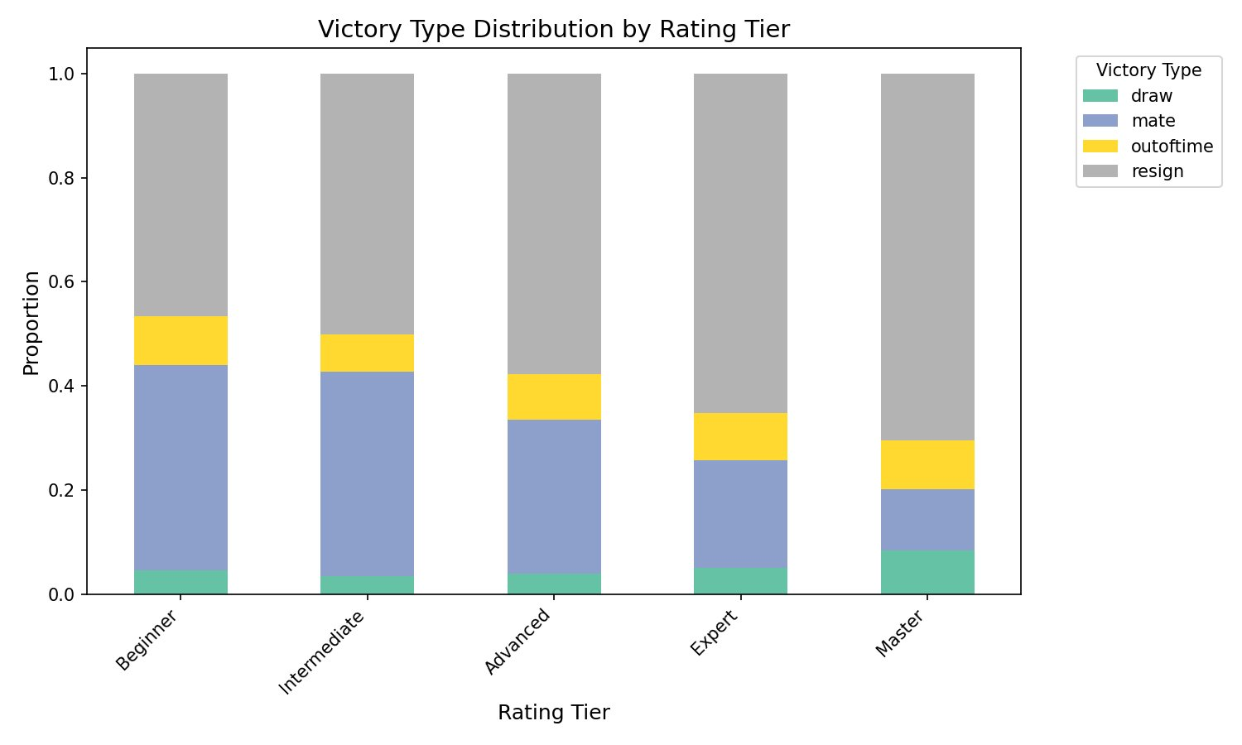
Figure 1. Stacked bar chart showing the proportion of each victory type within each rating tier. Resign increases and mate decreases as rating increases.

Subgroup comparison by time control showed that Classical format has the lowest timeout rate at 5.5%, compared to Rapid at 9.6% and Bullet at 8.8%. This confirms that time pressure is an independent factor in how games end, separate from skill level.

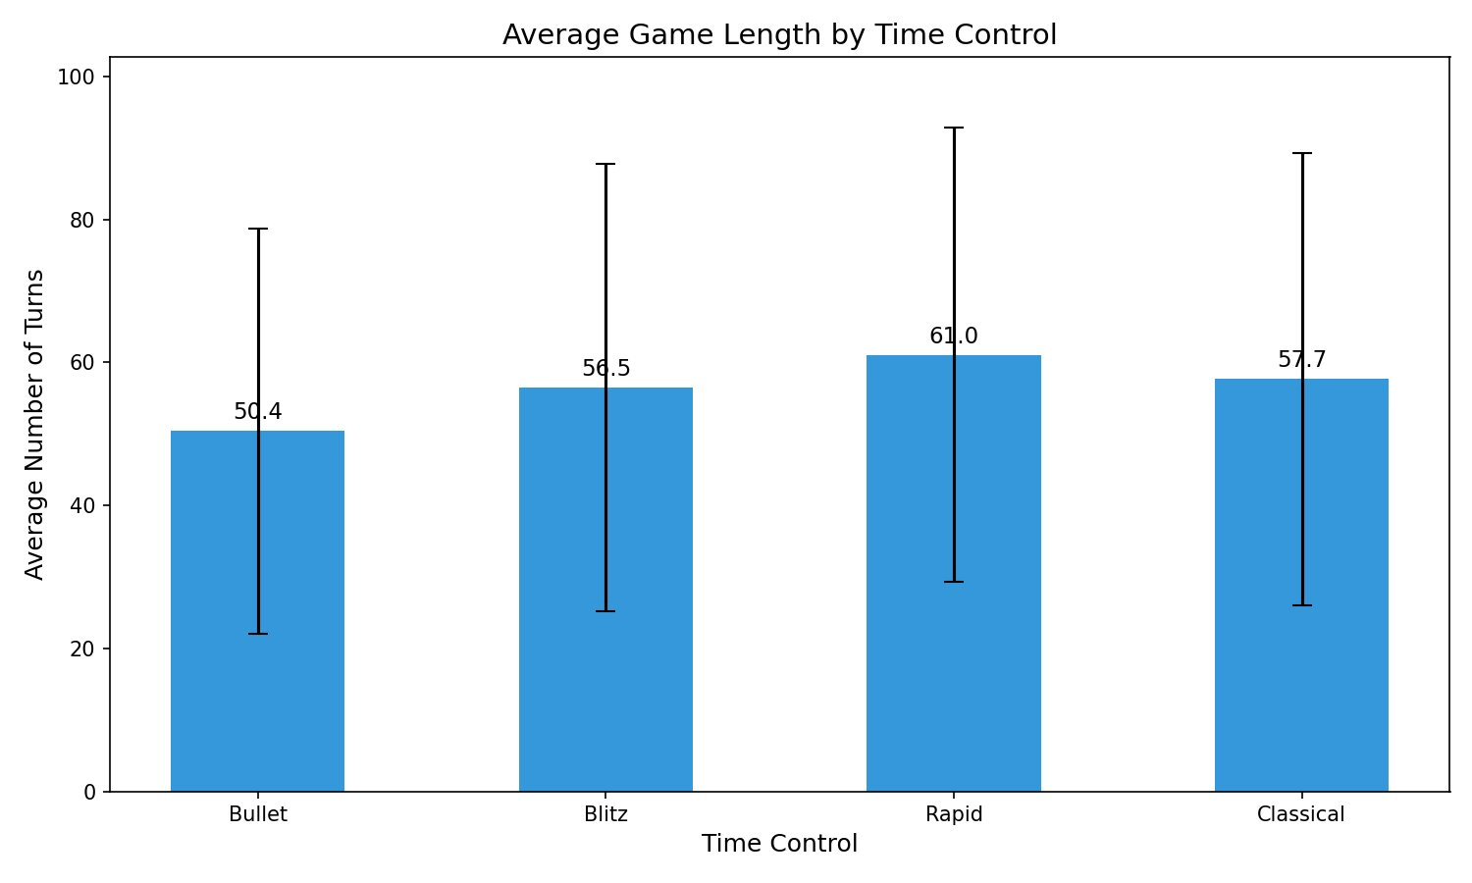
Figure 2. Bar chart showing average game length in turns by time control format. Error bars show one standard deviation. Bullet games average 50.4 turns while Rapid averages 61.0.

The NumPy correlation between absolute rating gap and number of turns was -0.125. This negative correlation confirms that mismatched games tend to end faster. The scatter plot below shows how resign endings (blue) are distributed across all gap sizes while mate and timeout cluster at lower gap values where both players are more evenly matched.

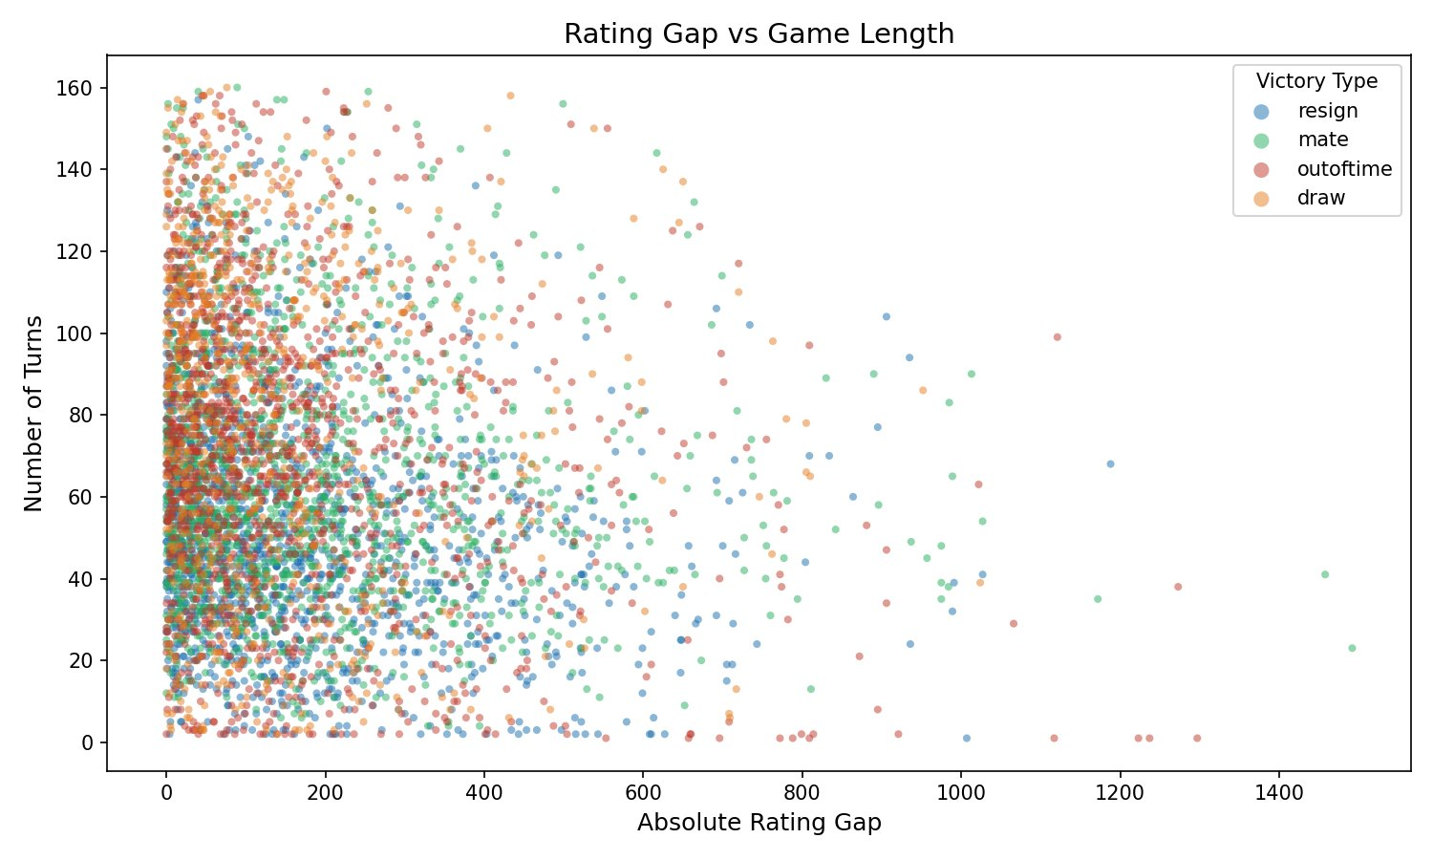
Figure 3. Scatter plot of absolute rating gap versus number of turns, colored by victory type. Each point is one game. The negative trend shows that larger mismatches produce shorter games.

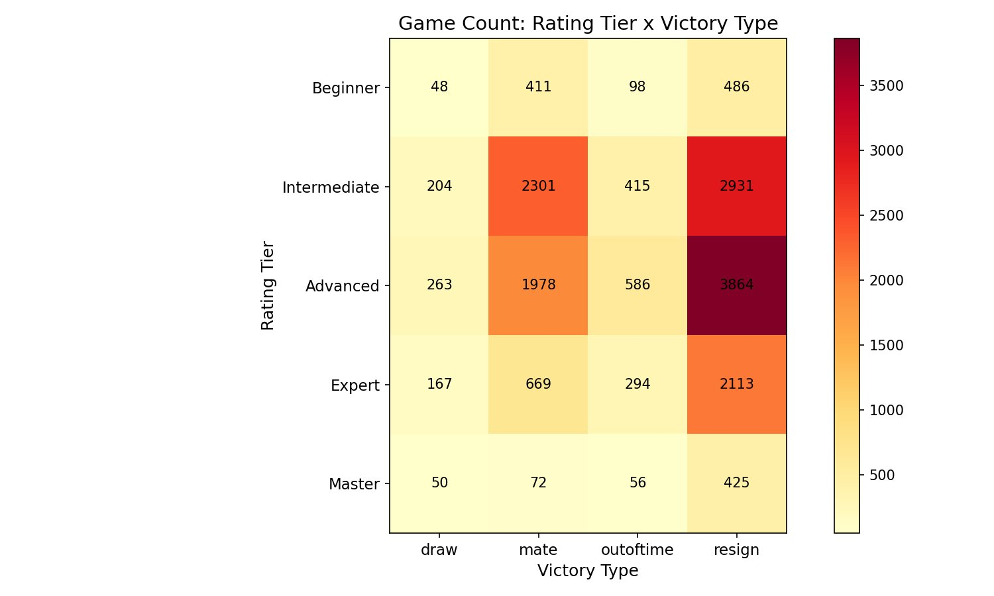
Figure 4. Heatmap of game count by rating tier and victory type. The Advanced tier has the highest volume. Resign dominates every tier and draw counts increase at Expert and Master level.

7.2 Research Question 2: Which openings give white the best and worst win rates?
To answer this question, white win rate was calculated for every opening family with 50 or more games. Of the 54 qualifying opening families, exactly 27 favor white (above 50%) and 27 favor black or are balanced at exactly 50%. The best performing opening for white is Queen's Pawn at 67.8% and the worst is Center Game at 31.6%, a spread of over 36 percentage points.

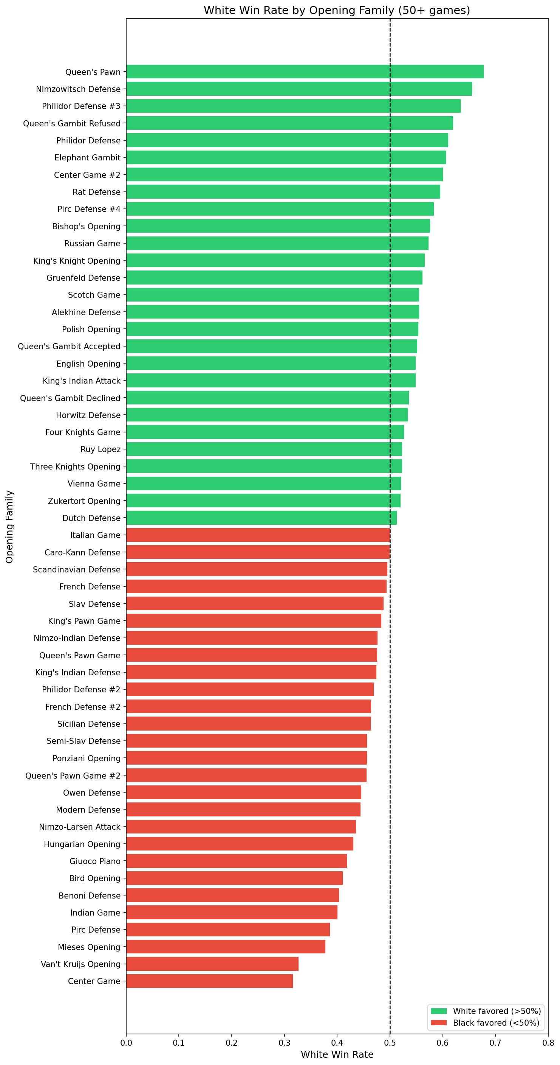
Figure 5. Horizontal bar chart showing white win rate for all 54 openings with 50 or more games. Green bars indicate white is favored (above 50%) and red bars indicate black is favored. The dashed line marks the 50% baseline.

The best and worst opening for white was also computed within each rating tier separately, using a minimum of 20 games per tier per opening. The results show that the best and worst openings differ considerably by tier. For example, Nimzowitsch Defense gives white an 80% win rate at Beginner level but this effect would not hold at higher tiers where both players know the theory better.

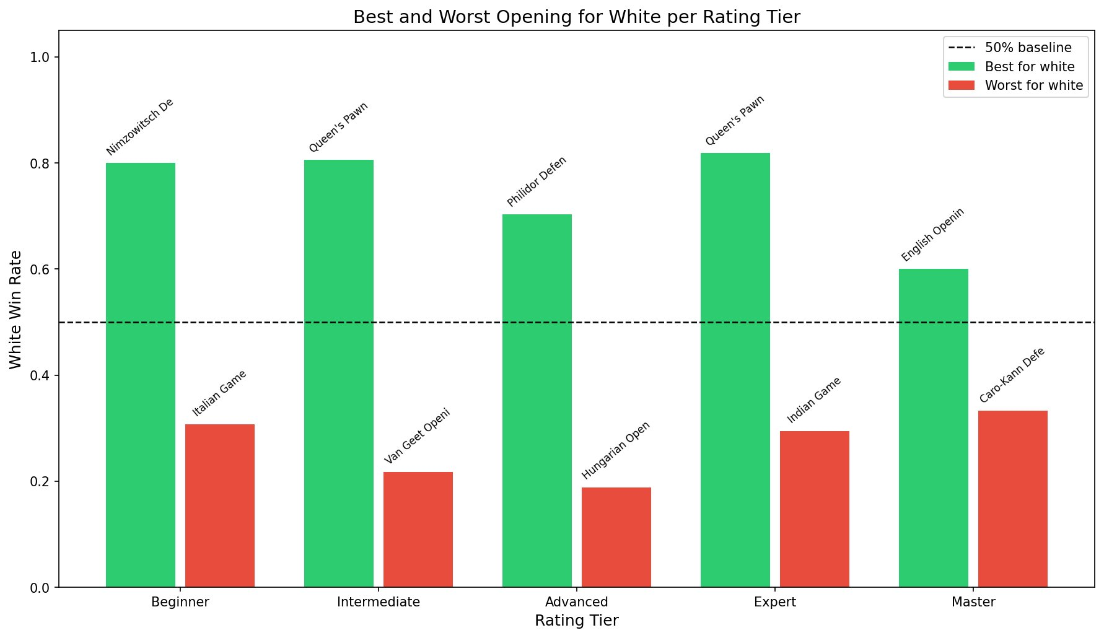
Figure 6. Grouped bar chart showing the best and worst performing opening for white within each rating tier, with a minimum of 20 games required. Green bars show the best and red bars show the worst. The dashed line marks 50%.

7.3 Research Question 3: How do opening preferences differ across rating tiers?
To answer this question, the top 5 most played opening families were identified within each rating tier. The results show clear differences in opening preferences across skill levels. The Sicilian Defense and French Defense appear in every tier but their relative positions shift. Beginner and Intermediate players tend to cluster around the same few popular openings, while Expert and Master players show more diverse choices.

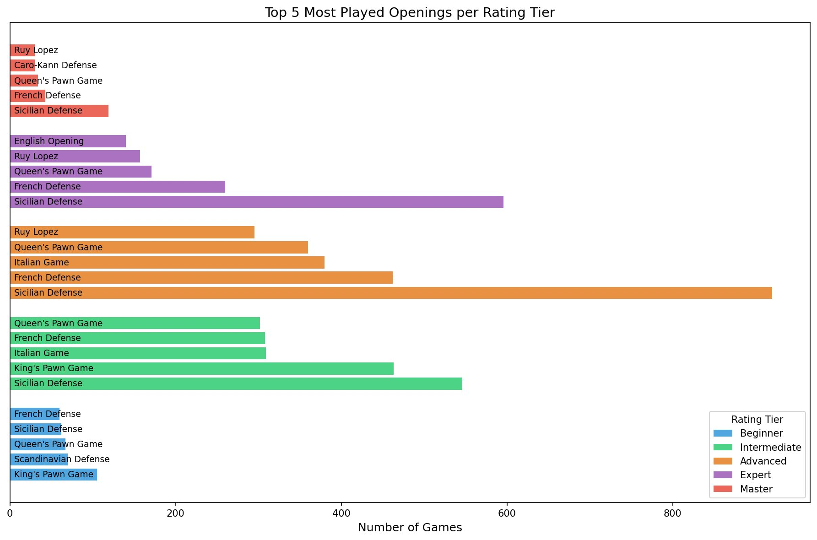
Figure 7. Horizontal bar chart showing the top 5 most played opening families within each rating tier. Each color represents one rating tier. Sicilian Defense dominates at Advanced and Expert level while Master players show more variety.

Additional analysis on draw rate by tier showed that the draw rate is lowest at Intermediate level (3.61%) and highest at Master level (8.29%), consistent with the idea that high-level play leads to theoretical equality more often. The upset rate analysis showed Bullet games have the highest upset rate at 35.2% versus Classical at 33.0%, suggesting that faster time controls slightly reduce the effective skill advantage.

8. NumPy-Based Custom Computations
Two meaningful NumPy computations were performed in this project beyond basic array operations.

Computation 1 | Pearson Correlation: np.corrcoef(df["rating_gap"].abs(), df["turns"])[0, 1]
Purpose | Measure the linear relationship between how mismatched the players are and how long the game lasts
Result | Correlation of -0.125, confirming that larger rating gaps produce shorter games on average
Takeaway | Mismatched games end decisively and quickly. This supports the finding that resign endings dominate when one player is clearly stronger
Computation 2 | Z-score outlier removal: z = (df["turns"] - df["turns"].mean()) / df["turns"].std(); df = df[np.abs(z) <= 3]
Purpose | Identify and remove statistically abnormal games that would skew distributions and correlation values
Result | 147 games removed (games with more than approximately 160 turns), leaving 17,431 clean rows
Takeaway | These games were genuine anomalies representing stalled or abandoned sessions rather than normal competitive play

9. Key Findings
- Resign is the dominant game ending at all skill levels, accounting for 56.3% of all 17,431 games. Its proportion grows consistently from 46.6% at Beginner to 70.5% at Master level, showing that recognizing a losing position is a skill that measurably improves with rating.
- Mate endings decrease sharply with rating. Beginners end 39.4% of games by checkmate while Masters reach checkmate in only 11.9% of games. This means stronger players resign well before the position is lost, a behavior that reflects strategic awareness rather than just technical ability.
- Time control format affects how games end independently of skill. Classical games have a timeout rate of only 5.5% compared to 9.6% in Rapid and 8.8% in Bullet, confirming that time pressure is a direct cause of timeout endings that cannot be explained by rating alone.
- Opening choice has a real and measurable effect on outcomes. Across 54 openings with 50 or more games, white win rates range from 31.6% (Center Game) to 67.8% (Queen's Pawn), a spread of over 36 percentage points. Exactly half of all qualifying openings favor white and half favor black.
- Draw rate peaks at Master tier at 8.29% compared to just 3.61% at Intermediate level. This is consistent with high-level chess theory: strong players on both sides find the best moves and reach positions where neither side can break through.
- Upset rate is highest in Bullet format at 35.2% versus 33.0% in Classical. This small but consistent difference suggests that time pressure slightly reduces the advantage that higher-rated players normally hold, giving lower-rated players a marginally better chance in faster games.
- Opening preferences shift noticeably across rating tiers. Beginner and Intermediate players cluster around a small set of popular openings. Master players show greater diversity in their opening choices, which is consistent with having broader theoretical preparation.
- The best and worst openings for white differ by rating tier. An opening that gives white an 80% win rate at Beginner level may perform very differently at Expert level where both players understand the theory. This finding shows that opening effectiveness depends on the skill context, not just the moves themselves.

10. Limitations
- Correlation does not imply causation. All relationships found in this analysis are associative. For example, higher rating correlating with more resign endings does not prove that rating causes the behavior. Other unmeasured factors such as experience, playing style, or game culture on Lichess could contribute to the patterns observed.
- The dataset is not a random sample. The 20,058 games were collected from a selection of Lichess users, which may over-represent certain rating ranges or play styles. The dataset contains significantly more Intermediate and Advanced games than Beginner or Master games, which could affect the generalizability of tier-level findings.
- Game duration is estimated, not measured. The timestamp columns in this dataset had identical precision and could not be used to calculate actual game duration. Duration was approximated using the formula (time_base x 2) + (turns x time_increment / 60), which gives a theoretical upper bound rather than exact elapsed time.
- The moves column was not analyzed. The full game notation was available in the dataset but analyzing individual move quality requires a chess engine such as Stockfish, which is outside the scope of this project. Move-level analysis could reveal much deeper patterns about how skill differences manifest in actual play.
- Findings are platform-specific. Lichess has its own culture around resignation, time management, and opening popularity that may differ from Chess.com or over-the-board tournament play. The results should not be generalized beyond online Lichess games without further validation.

11. Conclusion
This project used 17,431 cleaned chess games from the Lichess platform to investigate how skill level, time control, and opening choice influence game outcomes. Three research questions were addressed using Pandas groupby analysis, NumPy correlation and z-score computation, and Matplotlib visualizations.

The most consistent finding across all analyses is that skill level shapes game behavior in measurable and predictable ways. Stronger players resign more, draw more, and play a more diverse set of openings. Weaker players play longer before conceding, lose by checkmate more often, and cluster around a smaller set of popular openings. Time control adds an independent layer to this: faster formats produce more timeout endings regardless of rating, and they also give lower-rated players a slightly better chance of an upset.

Opening choice was found to matter, but its effect is context-dependent. An opening that works well at Beginner level may not perform the same way at Expert level, where both players have deeper theoretical knowledge. This suggests that opening effectiveness is as much about the opponent's familiarity as it is about the opening itself.

Future work could extend this analysis by using a chess engine to evaluate move quality per game, enabling direct comparison of decision-making accuracy across rating tiers. Adding a time-series component using Lichess API data would also allow analysis of how player behavior evolves over time as their rating changes.

12. References / Dataset Source
- Dataset: Chess Game Dataset (Lichess) — https://www.kaggle.com/datasets/datasnaek/chess
- Platform: Lichess.org — https://lichess.org
- Project Repository: https://github.com/Rezwoan/The-Chess-Code
- Chart images: https://github.com/Rezwoan/The-Chess-Code/tree/main/images/charts
- Python Libraries: Pandas, NumPy, Matplotlib, Scikit-learn (documentation at pandas.pydata.org, numpy.org, matplotlib.org)

